HW #2

1)

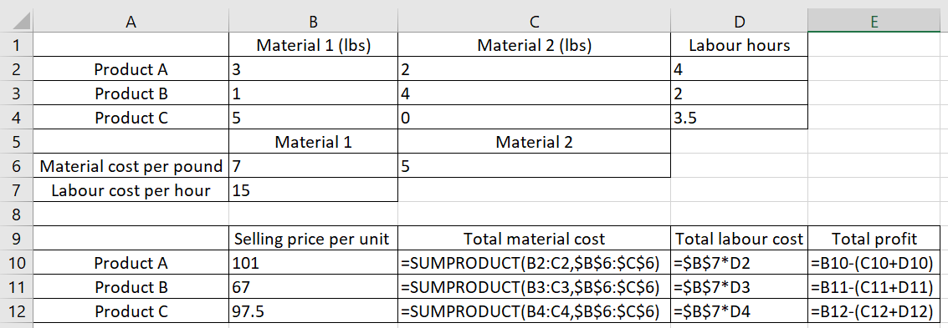

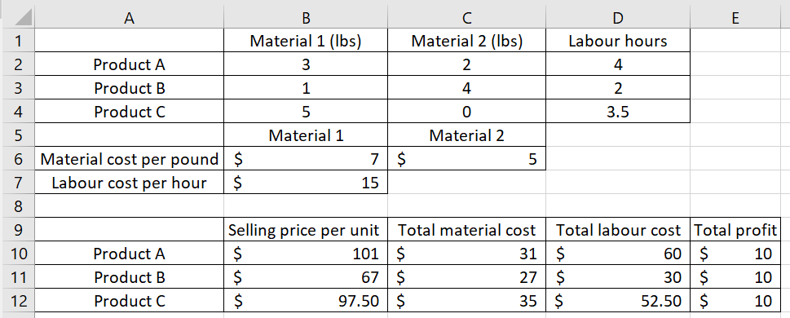

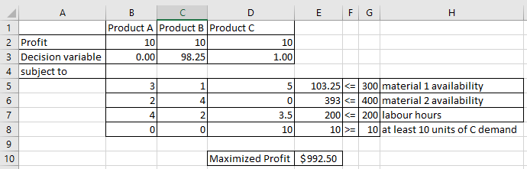

Thus, to maximize the profit, the manager should produce 98.25 B's and 1 C

2)

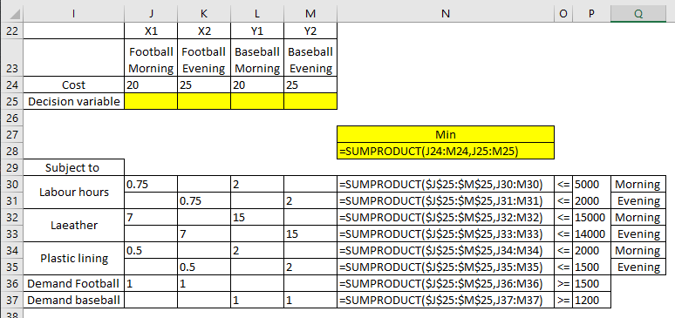

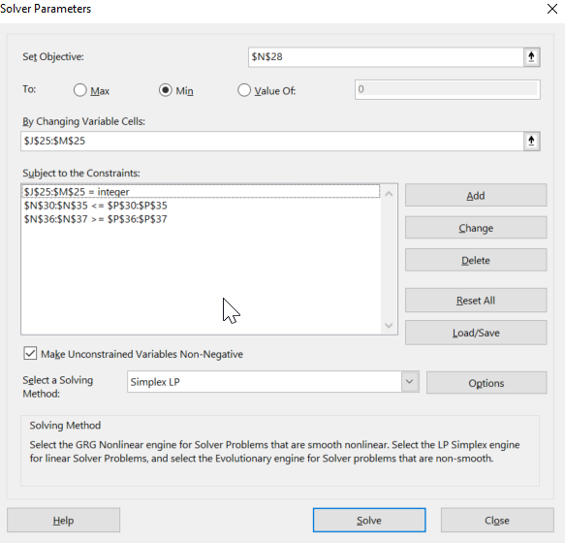

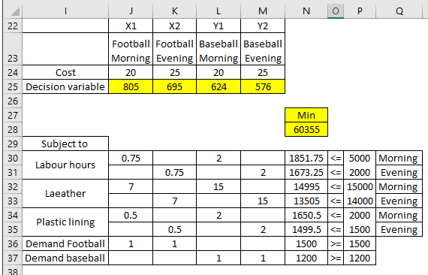

Football Morning Football Evening Baseball Morning Baseball Evening 805 624 576 695

3)

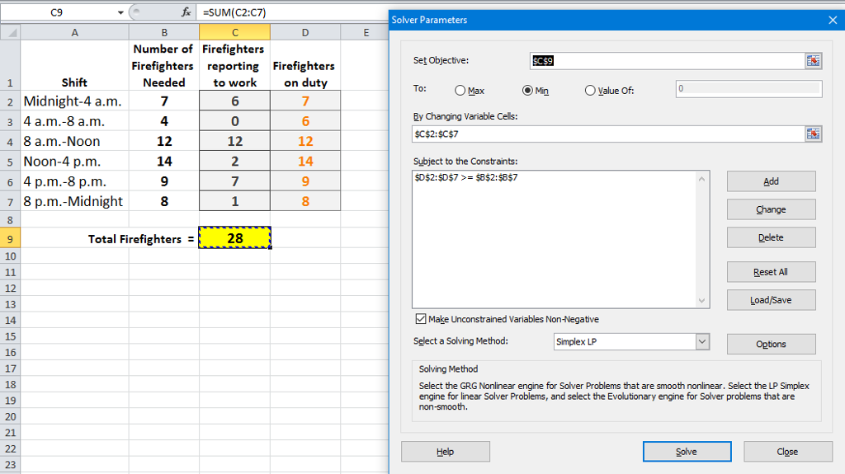

4)

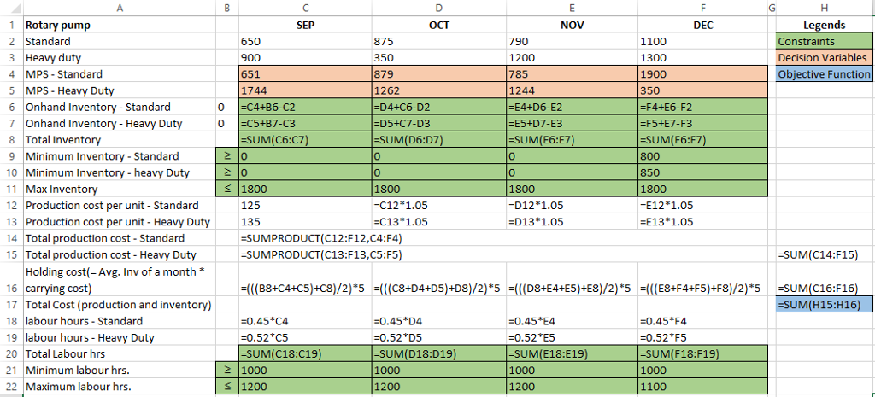

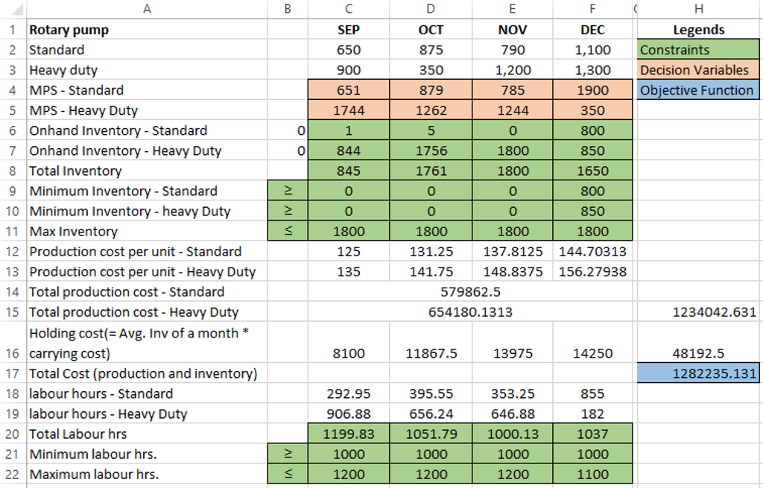

5)

a) 3 small and 44 large

B) 3\*600+3\*750+44\*1000= 48050

C) 100000-48200=51800

D) optimal number of office sizes would remain the same as the increase of 200 is within allowable limits. Objective function value would increase by 3\*200= 600. Thus the value of objective function is 48800.

E) the additional footage will have no effect as we have already exhausted the number of offices allowed with footage to spare.

F) since the allowable increase in rent for small and allowable decrease in the rent of large are greater than the changes as mentioned in the question there will be no change in allocation. The value of objective function would change by 50\*3 -200\*44=-8650.new value would be 48050-8650=39400